Dear Reaxys user,
Registration codes enable you to register and set up your username and password. Please note that the registration codes are unique and can only be used once.
Please follow the steps below in order to complete the registration process:
Go to https://new.reaxys.com/#/bulk. Using the Registration ID and Password you received, enter them in the Registration ID Redemption window shown below (make sure not to leave any empty spaces after the registration numbers). Then press ‘Continue’.

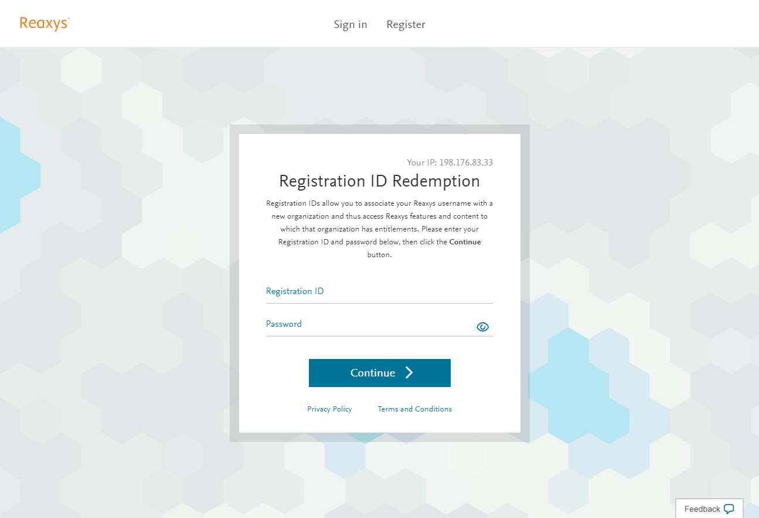

Please complete the registration form and click “Register”.
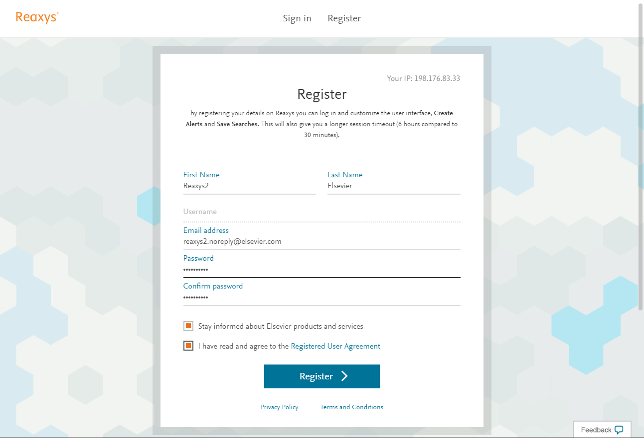

When you complete the form with your details (name and email address) and set your password, you will receive a permanent username. Please note that the username is case sensitive.
If you agreed to receive product emails you will be asked for further details:
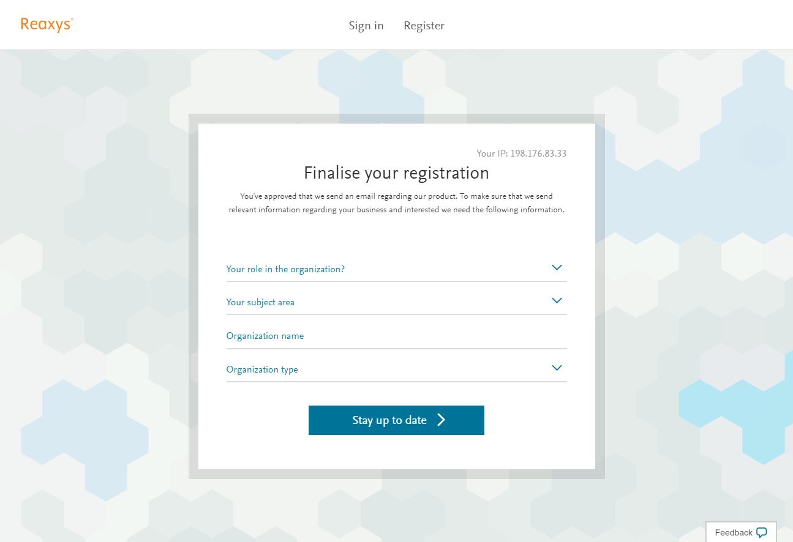
Once the registration process is complete by clicking ‘Stay up to date’, you will automatically be logged on to New Reaxys. The next time you go to https://new.reaxys.com, log in with your username and password.
